FLORIDA * TEXAS * CALIFORNIA * WASHINGTON * NEW ENGLAND * DAYTON * EUROPE * UNITED KINGDOM * SINGAPORE * POLAND * INDIA
(954) 724 - 1400
(800) 733 - 0960
(954) 721 - 5050 Fax

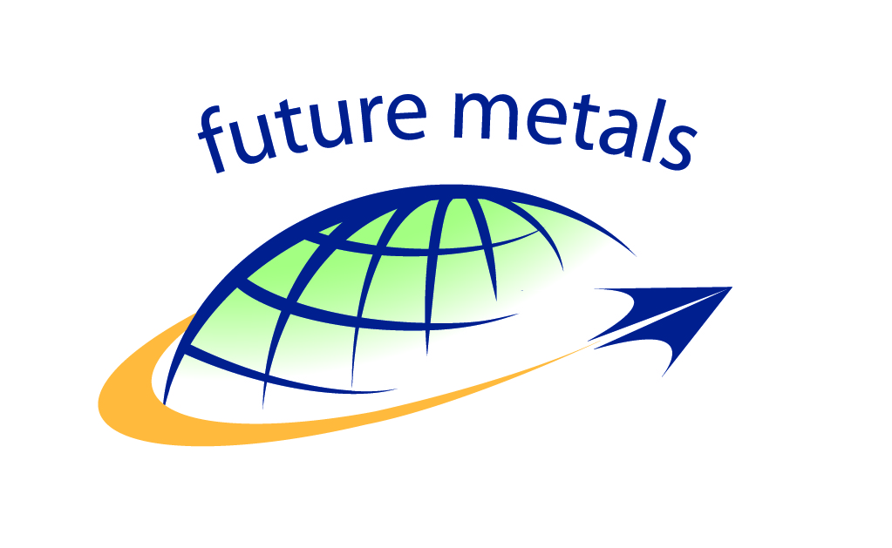
Tamarac, FL, February 10th, 2022

REACH & SVHC Declaration (FM-DEC-8-REACH & SVHC Declaration)

FROM: Kenny Bailey, Quality, Safety & ECC Manager Non-USA divisions ; Darnell Louis, Purchasing Director;
Phil Hilt, Quality Manager USA.

TO: TO WHOM IT MAY INTEREST

SUBJECT: Declaration regarding Compliance with REGULATION (EC) No. 1907/2006 OF THE EUROPEAN PARLIAMENT AND OF THE COUNCIL of 18 December 2006 concerning the Registration, Evaluation, Authorization and Restriction of Chemicals (REACH) within the supply chain.

REFERENCE
The European Regulation (EC) No. 1907/2006 concerning the Registration, Evaluation, Authorization and Restriction of Chemicals (REACH) entered into force on June 1, 2007 (https://ec.europa.eu/environment/chemicals/reach/reach_en.htm). REACH addresses the production and use of chemical substances, and their potential impacts on both human health and the environment. REACH purpose is to ensure human and environmental health by regulating Substances of Very High Concern, or SVHC’s, as detailed in: https://www.echa.europa.eu/candidate-list-table.

JUSTICATION
As an AS9100 Rev D. Certified Provider of Products & Services, we are required to comply with all the sections of the standard and those of any other applicable regulatory requirements, particularly related to Sec.8.2 (Requirements for Products and Services), Sec.8.4 (Control of Externally Provided Processes, Products and Services) and Sec.8.4.3 (Information for External Providers), whilst our Suppliers are expected to comply with our “Terms & Conditions” and “Suppliers Code of Conduct”.

STATEMENT OF COMPLIANCE
As of January 17th, 2022, Future Metals has determined that (1) none of its distributed products has any SVHC substances in concentrations above the minimums contained in the legislation and that (2) None of our products consist of chemical substances requiring registration or raw materials in any form. Because of this, Future Metals LLC and Future Metals UK are not required, under REACH, to distribute Safety Data Sheet’s or Exposure Scenario’s to our end users.

External providers of articles to Future Metals and/or its subsidiaries shall provide us enough information if the article contains a SVHC in a concentration above 0.1% weight by weight (w/w). As there is no statutory information duty for the suppliers if no SVHC listed on the candidate list are contained in articles provided to us, Future Metals will assume the absence of such SVCH with respect to articles delivered without any information according to Art. 33 REACH.

Future Metals will continue to monitor our suppliers, and if any substances that require registration begin to be included in our products, we will inform our customers according to the REACH legislation.

Thank you very much in advance for your attention.
Your sincerely,

K.Bailey Darnell Louis
Kenny Bailey – Quality, Safety and ECC Manager Non-USA divisions Darnell Louis - Purchasing Director
kbailey@futuremetals.com dlouis@futuremetals.com

P.Hilt
Phil Hilt – Quality Manager | Americas
philt@futuremetals.com

Future Metals LLC

CORPORATE OFFICE
P.O. Box 26450 Tamarac, FL 33320

